# Lesson 76 单词讲解

1. fool n. 傻瓜

April Fools’ Day

foolish adj. 傻的，愚蠢的

1. bulletin n. 新闻简报

news bulletin

bulletin board 布告牌

electronic bulletin board 电子布告牌

1. process v. 加工

The crop is processed in the local factory.

n. 过程，进行；方法，步骤

We do a lot of practice in the learning process.

1. studio n. 播音室，工作室

a film studio 电影工作室

an art studio 艺术工作室

3 announcer [ə'naunsə] n.(电视、电台)播音员

4 macaroni [ˌmækə'rəuni] n.通心面，空心面条

5 leading ['li:diŋ] a.主要的

6 grower ['grəuə] n.种植者

7 splendid ['splendid] a.极好的

8 stalk[stɔ:k] n.梗

9 gather ['gæeə] v.收庄稼

10 thresh [θreʃ] v.打(庄稼)

11 process['prəuses] v.加工

12 signor ['si:njɔ:] n.(意大利语)先生

13 present [pri'zent, 'prezənt] a.目前的

14 champion ['tʃæmpiən] n.冠军

15 studio ['stju:diəu] n.播音室

# Lesson 76 课文&语法讲解

本课重点:

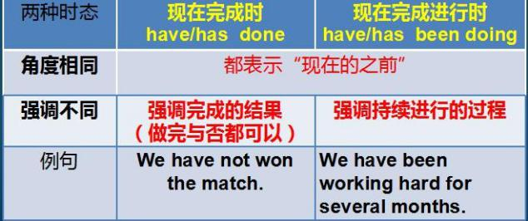复习现在完成时 vs. 现在完成进行时复习从句

1. 'To end our special news bulletin,’ …… 'we're going over to the macaroni fields of Calabria.

1. Macaroni has been grown in this area for over six hundred years.
2. Two of the leading growers, Giuseppe Moldova and Riccardo Brabante, tell me that they have been expecting a splendid crop this year and harvesting has begun earlier than usual.
3. Here you can see two workers who, between them, have just finished cutting three cartloads of golden brown macaroni stalks.
4. The whole village has been working day and night gathering and threshing this year's crop before the September rains.
5. She has been helping her husband for thirty years now.
6. Mrs. Brabante is talking to the manager of the local factory where the crop is processed.
7. This last scene shows you what will happen at the end of the harvest: the famous Calabrian macaroni-eating competition!
8. Signor Fratelli, the present champion, has won it every year since 1991.
9. And that ends our special bulletin for today, Thursday, April lst. We're now going back to the studio.'

# Lesson 76 知识拓展

补充内容:

April Fools’ Day

April Fools’ Day

April Fool's Day is traditionally a day to play practical jokes on others.

No one knows how this holiday began but it was thought to have originated in France.

April Fools’ Day

The closest point in time that can be identified as the beginning of this tradition was in 1582, in France.

New Year's was celebrated on March 25 and celebrations lasted until April 1st.

April Fools’ Day

When New Year's Day was changed from March 25 to January 1st in the mid-1560's by King Charles IX,

there were some people who still celebrated it on April 1st and those people were called April Fools.

